Sample Abstracts for GSEF

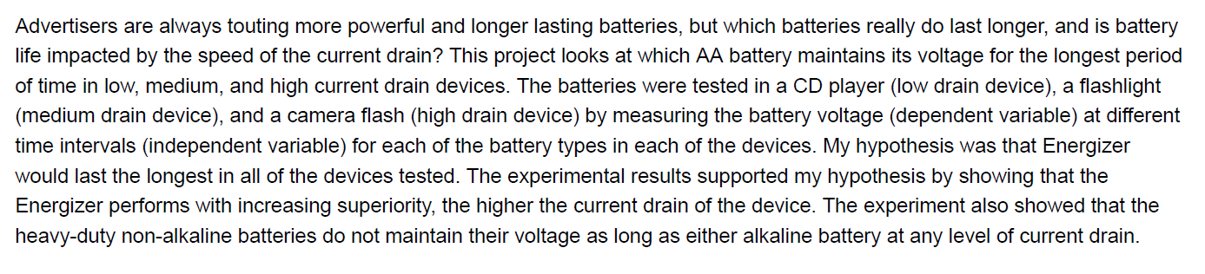

The objective of this science project is to study the correlation between muscle development and the amount of stress exerted on to the muscles during exercise. Being familiar and knowledgeable about the proper stress placement techniques on muscles will enable up & coming high school athletes to adopt the correct workout manners. The proposed hypothesis stated that exposing muscles to a three (3) second strain duration will result in optimal gain in muscle mass. In order to test the hypothesis, three high school seniors with same age, same height and same weight performed a workout routine with different stress duration for one month. The body muscle-to-fat ratios were measured both before starting the workout routine and at the end of the one-month time-period. During the project, the daily workout time, diet plan and calorie intake remained the same for each of the three subjects. At the end of the month’s duration, the subject who exposed his muscles to a 4-second strain period during the workout sessions registered the maximum gains in muscle mass. The study enables and equips aspiring high school athletes to rectify & modify their current workout practices to get the most out of their exercise routine & efforts.

